Tree Walk 1 – Lanark Road - Old Post Office to Gillespie Crossroads

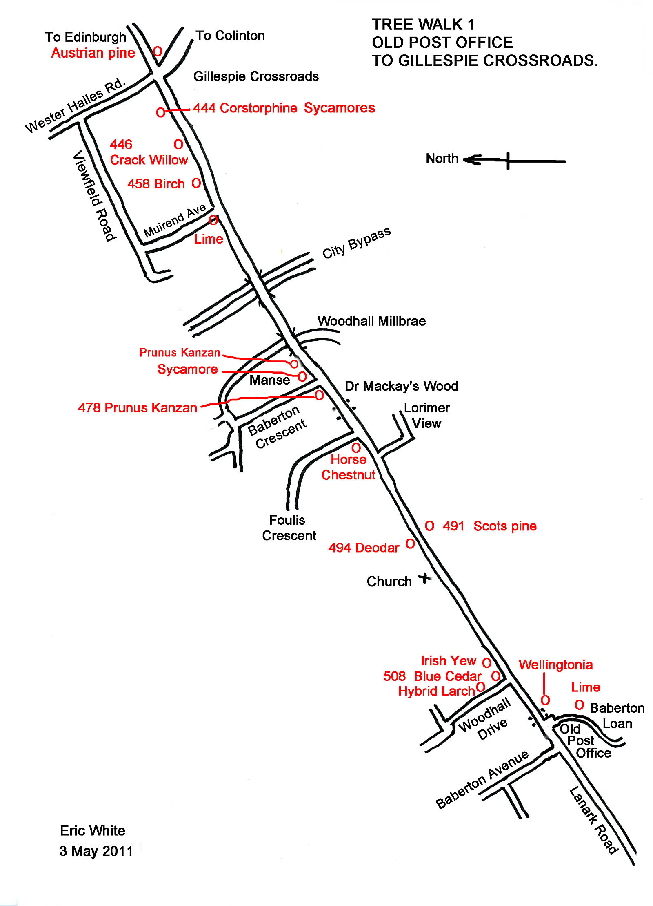

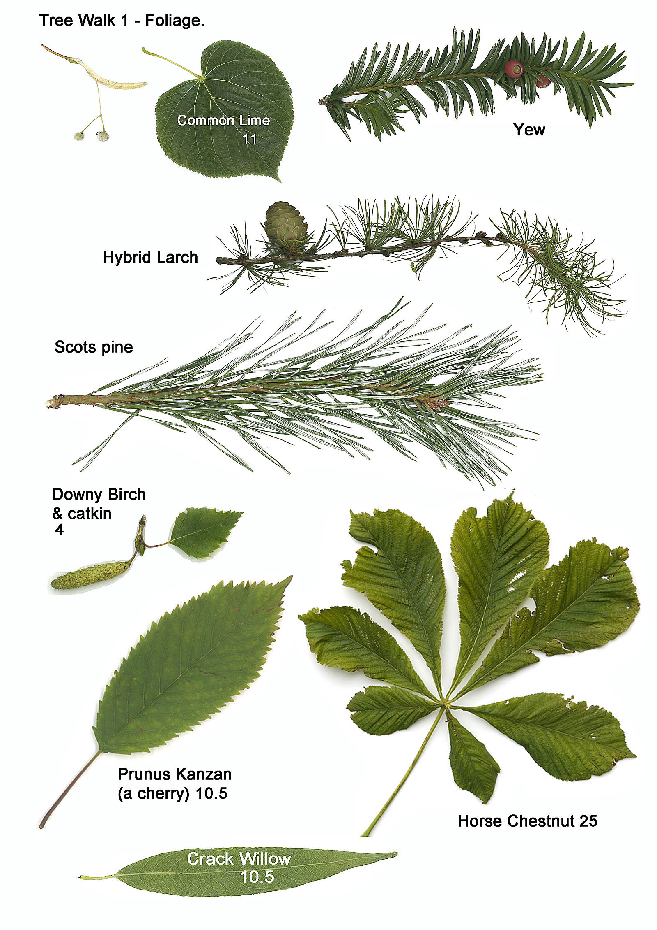

Tree walk 1 – tree descriptions

1. Wellingtonia Sequoiadendron giganteum.
The Wellingtonia and the coast redwood, Sequia sempervirens grow in the western USA to some 110 metres. Both have soft deep bark which preserves them from fire and enables them to reach a great age. The Wellintonia has scale leaves, whereas the redwood has needles resembling those of yew.

2. Common Lime Tilia x europaea.
A large (up to 40 metres) tree with yellowish-green hairless oval leaves, which usually has epicormic shoots arising around the base. Several seeds are suspended from one wing.

3. Hybrid larch Larix eurolepis.
The larches have deciduous needles in tufts. The first to be imported was the European larch with straw-coloured twigs, and which suffers a canker disease. Then came the Japanese larch with purple-red twigs. The hybrid larch combines their good qualities, and has intermediate-coloured twigs.

4. Irish Yew Taxus baccata.
Yew has a small nut with a fleshy red covering. The Irish one has upright branches whereas the English one has spreading branches. It is poisonous to animals. .

5. Deodar or Indian cedar Cedrus deodara.
Cedars have evergreen needles in tufts. The bark is black.

6. Scots pine Pinus sylvestris
This is the native pine of Scotland. It’s a two-needle pine with blue-green needles and bark, tending to be orange when old, and totally orange in the crown. The tree is pyramidal when young but tends to be flat-topped when old. The buds are pointed and tend to orange.

7. Horse chestnut Aesculus hippocastanum.
The leaves are large & compound with a palmate arrangement. The flowers are in candles with various colours according to species. The fruit is the conker, loved by small boys.

8. Prunus Kanzan (a cherry) Prunus “Kanzan”.
A small tree widely planted in streets with conspicuous pale pink flowers in spring, the branches tending upwards as in the spokes of an umbrella.

9. Sycamore Acer pseudoplatanus.
An introduced tree disliked by conservationists. It causes dense shade and is too successful competing with native species. The bark has a plated appearance. Seeds are in winged pairs. It usually has Tar-Spot disease on the leaves.

10. Downy birch Betula pubescens.
This is the northern birch, with tiny hairs on its twigs. The bark is generally less conspicuously white than in B. pendula. Both birches hybridise easily.

11. Crack willow Salix fragilis.
A tree which grows up to 15 or even 25 metres. With lanceolate leaves.

12. Corstorphine Sycamores, a local variety with conspicuous yellow foliage in spring, changing later to green.

13. Austrian pine Pinus nigra. ssp. nigra.
This two-needle pine has dark green needles and a black trunk. One of these has an unusually rough bark.

